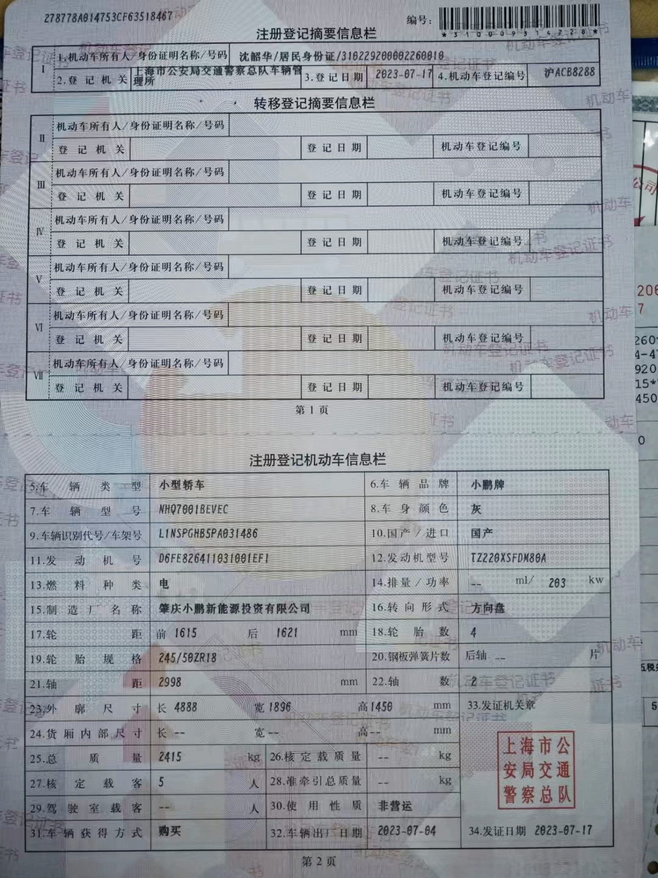
Serial No.: 278778A014753CF63518467 | No.: 310009314228
Registration Summary Information
I | 1. Motor Vehicle Owner / Identification Document / No. |  | SHEN SHAOHUA / Resident Identity Card / 310229200002260010
 | 2. Registration Authority | Vehicle Administration Office of the Traffic Police Corps of Shanghai Public Security Bureau |  | 3. Registration Date | 2023-07-17 | 4. Motor Vehicle Registration Number | HU ACB8288
Transfer Registration Summary Information
II | Motor Vehicle Owner / Identification Document / No.
 | Registration Authority |  | Registration Date |  | Motor Vehicle Registration No.
III | Motor Vehicle Owner / Identification Document / No.
 | Registration Authority |  | Registration Date |  | Motor Vehicle Registration No.
IV | Motor Vehicle Owner / Identification Document / No.
 | Registration Authority |  | Registration Date |  | Motor Vehicle Registration No.
V | Motor Vehicle Owner / Identification Document / No.
 | Registration Authority |  | Registration Date |  | Motor Vehicle Registration No.
VI | Motor Vehicle Owner / Identification Document / No.
 | Registration Authority |  | Registration Date |  | Motor Vehicle Registration No.
VII | Motor Vehicle Owner / Identification Document / No.
 | Registration Authority |  | Registration Date |  | Motor Vehicle Registration No.
Page 1

Registered Motor Vehicle Information
5. Vehicle Type | Small Sedan |  | 6. Vehicle Brand | XPENG
7. Vehicle Model | NHQ7001BEVEC |  | 8. Body Color | Gray
9. Vehicle Identification No. / VIN | L1NSPGHB5PA031486 |  | 10. Domestic / Imported | Domestic
11. Engine No. | D6FE826411031001EF1 |  | 12. Engine Model | TZ220XSFDM80A
13. Fuel Type | Electricity |  | 14. Displacement / Power | -- ml / 203 kW
15. Manufacturer | Zhaoqing XPeng New Energy Investment Co., Ltd. |  | 16. Steering Type | Steering Wheel
17. Track | Front: 1615 mm; Rear: 1621 mm |  | 18. Number of Tires | 4
19. Tire Size | 245/50ZR18 |  | 20. Number of Leaf Springs | Rear axle: -- piece(s)
21. Wheelbase | 2998 mm |  | 22. Number of Axles | 2
23. Overall Dimensions | Length: 4888 mm; Width: 1896 mm; Height: 1450 mm |  |  | 33. Issuing Authority Seal  Traffic Police Corps of Shanghai Public Security Bureau
24. Cargo Compartment Internal Dimensions | Length: --; Width: --; Height: -- mm
25. Gross Vehicle Mass | 2415 kg | 26. Approved Load Mass | -- kg
27. Approved Passenger Capacity | 5 persons | 28. Gross Mass of Semi-trailer | -- kg
29. Cab Seating Capacity | -- persons | 30. Nature of Use | Non-commercial
31. Method of Acquisition | Purchase | 32. Date of Manufacture | 2023-07-04 | 34. Date of Issue 2023-07-17
Page 2

Translator Declaration:
I, GAO YINGHAO, the undersigned translator, hereby certify that the attached English translation is true, complete and accurate to the original Chinese document.
I passed the Test for English Majors – Band 8 (TEM-8) in 2023. Chinese is my native language, and I have professional proficiency in English, enabling me to provide accurate and complete Chinese-to-English translations.
Full Name: GAO YINGHAO
Email: 1067403101@qq.com
Mobile: +86 17317374963
Date: 18 August 2026
Signature: (Not required for electronic submission)

